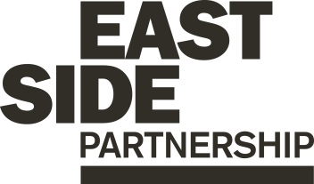

Job Description ESP/ESGYPC22

Project: EastSide Greenways

Job Title: Youth Project Coordinator

Location: EastSide Partnership, Avalon House

Reports to: EastSide Greenways Manager

Terms and conditions

Salary: Starting on NJC Point 19, on a scale of points 19–25, currently £25,927 - £30,095, + 7.5% pension

Contract: This post is a permanent post, however it is dependent on future funding, which is currently secured until August 2024. Job subject to 6 month probation period.

Holidays: 25 days per year plus statutory holidays.

Hours of work: 37.5 hours per week but willingness to work flexible hours including evenings and weekends is essential.

The following gives an indication of the current main duties and responsibilities of the post. The post holder will be expected to work flexibly and carry out any other duties appropriate to the role which may reasonably be required from time to time.

Main Purpose of Job

The main purpose of this role is to:

Plan, coordinate and deliver the EastSide Greenways Personal Youth Development Programme (PYDP) which is a personal development, skills development and employability programme.

Support the EastSide Greenways Manager to engage with youth related organisations in east Belfast.

Report and evaluate on the PYDP throughout the 2-year programme.

Summary of responsibilities and personal duties

- Lead on the development, planning and delivery of a 2-year Personal Youth Development Programme (PYDP) working intensively with at risk young people aged 16 – 25 years not in employment, education or training, focusing on; personal development & good relations, skills & social development, education & employability development and developing community champions.

- Lead on the recruitment of 15 young people to engage with the programme.

- Ensure the delivery of 3 days of engagement per week throughout the programme themed on the above focus areas.

- Support the participating young people in the completion of the programme and provide mentoring support for them as they make positive changes in their lives.

- Facilitate elements of the programme where required including the delivery of OCN accredited training programmes to groups of young people.

- Source and book relevant third party facilitators, trainers and suppliers to deliver elements of the programme where required.

- Offer 1-2-1 support to participants throughout their engagement in the programme.

- Lead on the planning and delivery of trips, visits, volunteering opportunities, educational and vocational talks for programme participants.

- Facilitate a quarterly steering group made up of key representatives in east Belfast in relation to the programme.

- Be responsible for maintaining accurate records, stored appropriately and with respect to confidentiality.

- Carry out regular monitoring and evaluation of the programme acting as the main point of contact for the funder.

- Liaise with other key agencies to build a network of support for young people and ensure the programme can adapt to the changing issues for young participants.

- Undertake other duties relevant to the role including:
- Provide day to day project administration and support
- Manage relevant resources and equipment
- Attend training courses and conferences as required
- Report against objectives to ensure outcomes are being met and that monitoring and evaluation is undertaken
- Act in accordance with EastSide Partnership’s policies and procedures
- Undertake such other relevant duties as may from time to time be required
Person Specification ESP/ESGYPC22

 | Essential | Desirable
Attainments/ Education | - A 3rd Level Qualification in a related field and a minimum of 1 years’ experience in a similar role gained in the last 5 years;  OR  A minimum of 3 years’ employment experience in a role related to community development, employability or youth development | - OCN Accreditation Training
Experience | - A minimum of 1 years’ experience gained in the last 5 years of;  - Managing projects/ events/ activities  - Working with young people  - Delivering training programmes | - Experience of;  - partnership working  - managing budgets  - facilitation  - community development
Skills | - Ability to establish and maintain positive relationships with young people  - Ability to be creative, innovative and work on own initiative  - Effective organisation skills with the ability to manage and prioritise workload and meet deadlines  - Excellent interpersonal and communication skills
Disposition | - Well presented & inspires confidence  -Offers a positive role model for young people  -Ability to deal with challenging situations  - Self-motivated and initiative taking  - Passionate, inspiring and dynamic  - Ability to work collaboratively and as part of a team  - Flexible and pragmatic
Knowledge & Values | - Knowledge of Connswater Community Greenway, EastSide Greenways and EastSide Partnership  -Understanding of youth sector in Belfast  - Commitment to regeneration and a partnership approach
Circumstances | - Willingness to work flexible hours including evenings and weekends

Equal Opportunities Monitoring Form ESP/ESGYPC22__

Private & Confidential

We are an Equal Opportunity Employer. We do not discriminate on grounds of religious belief or political opinion. We practice equality of Opportunity in employment and select the best person for the job.

To demonstrate our commitment to equality of opportunity in employment we need to monitor the community background of our applicants and employees, as required by the Fair Employment and Treatment (NI) Order 1998.

Regardless of whether we practice religion, most of us in Northern Ireland are seen as Catholic or Protestant. We are therefore asking you to indicate your community background by ticking the appropriate box below.

I am a member of the Protestant community

I am a member of the Roman Catholic community

I am a member of neither the Protestant nor Roman
Catholic community

Please indicate whether you are: Female

Male

If you do not complete this questionnaire, we are encouraged to use the “residuary” method, which means that we can make a determination on the basis of personal information on file/application form.

Note: It is a criminal offence under the legislation for a person to “give false information in connection with the preparation of the monitoring return”.

Application Process ESP/ESGYPC22

Application
- Completed applications must arrive by 12pm on Monday 21st November 2022

- Applications will only be accepted by email to gillian@eastsidepartnership.com and will be acknowledged by email. If not acknowledged please contact Gillian on 028 9045 1900

- Application MUST be by Application Form with minimum font size 11. You may also include a CV (max 2 x A4 pages, minimum font size 11) but please ensure that if you enclose a CV, you cover how you meet all criteria as detailed in the person specification, in your application form.

- To be accepted the application MUST include the monitoring form

- Only information contained in the application form and accompanying CV will be taken into account, so please ensure that you include all relevant information.

- We may only interview those applicants who appear, from the information provided, to be the most suitable in terms of the person specification provided.

Equal Opportunities
- EastSide Partnership is an equal opportunities employer. EastSide Partnership does not permit unlawful discrimination of any kind against any person on grounds which include gender, sexual orientation, marital status, religious belief or political opinion, race or disability. Unlawful discrimination is defined as treating a person less favourably than others are, or would be treated in the same or similar circumstances.

Canvassing
- Canvassing in any form will, if proved to the satisfaction of EastSide Partnership, disqualify a candidate for the appointment

Interviews
- Interviews will be held on Tuesday 29th November 2022. Please ensure your availability for interview on this date prior to application, as it will not be possible to arrange an alternative date

Job Description
- The duties outlined in the Job Description serve as a guide to the current and major responsibilities of the post. These will inevitably vary as the role develops and the Job Description will be reviewed on a regular basis. Changes will be subject to consultation with the post holder.

Background Information

EastSide Partnership is a local charity leading the regeneration of east Belfast. Working alongside other community-based organisations, elected representatives, statutory agencies and local businesses, EastSide Partnership delivers a wide variety of projects with a clear mission to ‘make east Belfast a better place’ for residents, businesses and visitors.

Our vision is that east Belfast will be a great place where:
- Residents enjoy good health and well being
- Education is valued and high standards achieved
- Tourism, arts and hospitality are thriving

EastSide Partnership aims to:
- Create an east Belfast that is a thriving cultural hub, where the arts are valued, creativity is for everyone and people are connected with each other and the wider world through EastSide Arts
- Promote the use and development of green open spaces, parks, rivers and off-road transport routes in east Belfast through EastSide Greenways including Connswater Community Greenway
- Help and support children in east Belfast to develop their abilities, reach their potential and experience success, whatever their background through EastSide Learning
- Contribute to the regeneration of east Belfast through the strategic acquisition, development and management of sites and properties through EastSide Property
- Coordinate and deliver responsible, sustainable and impactful culture-led regeneration, pushing boundaries to put east Belfast on the map through EastSide Tourism
- Raise awareness and help alleviate the impact of poverty in inner east Belfast through the Scaffolding Project

For more information please visit www.eastsidepartnership.com
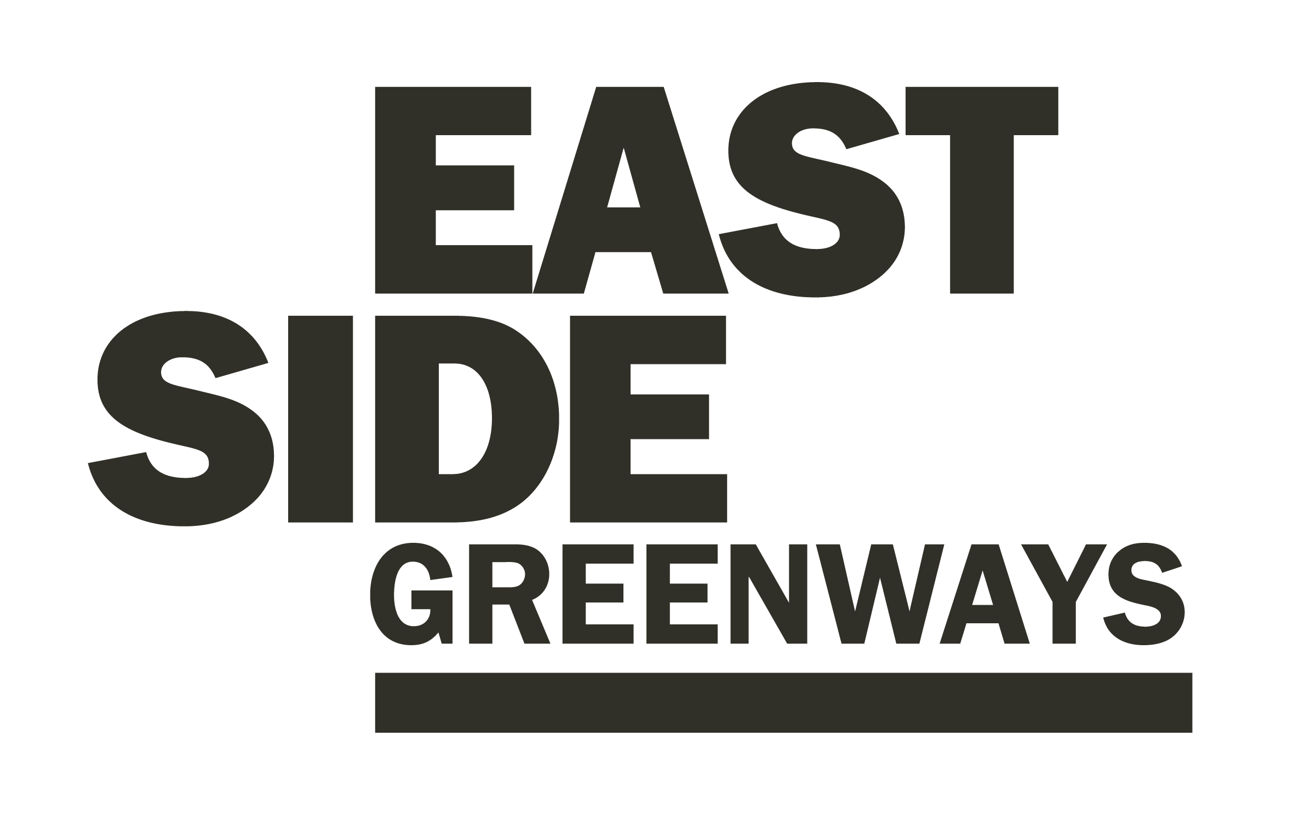

EastSide Greenways- Additional Information

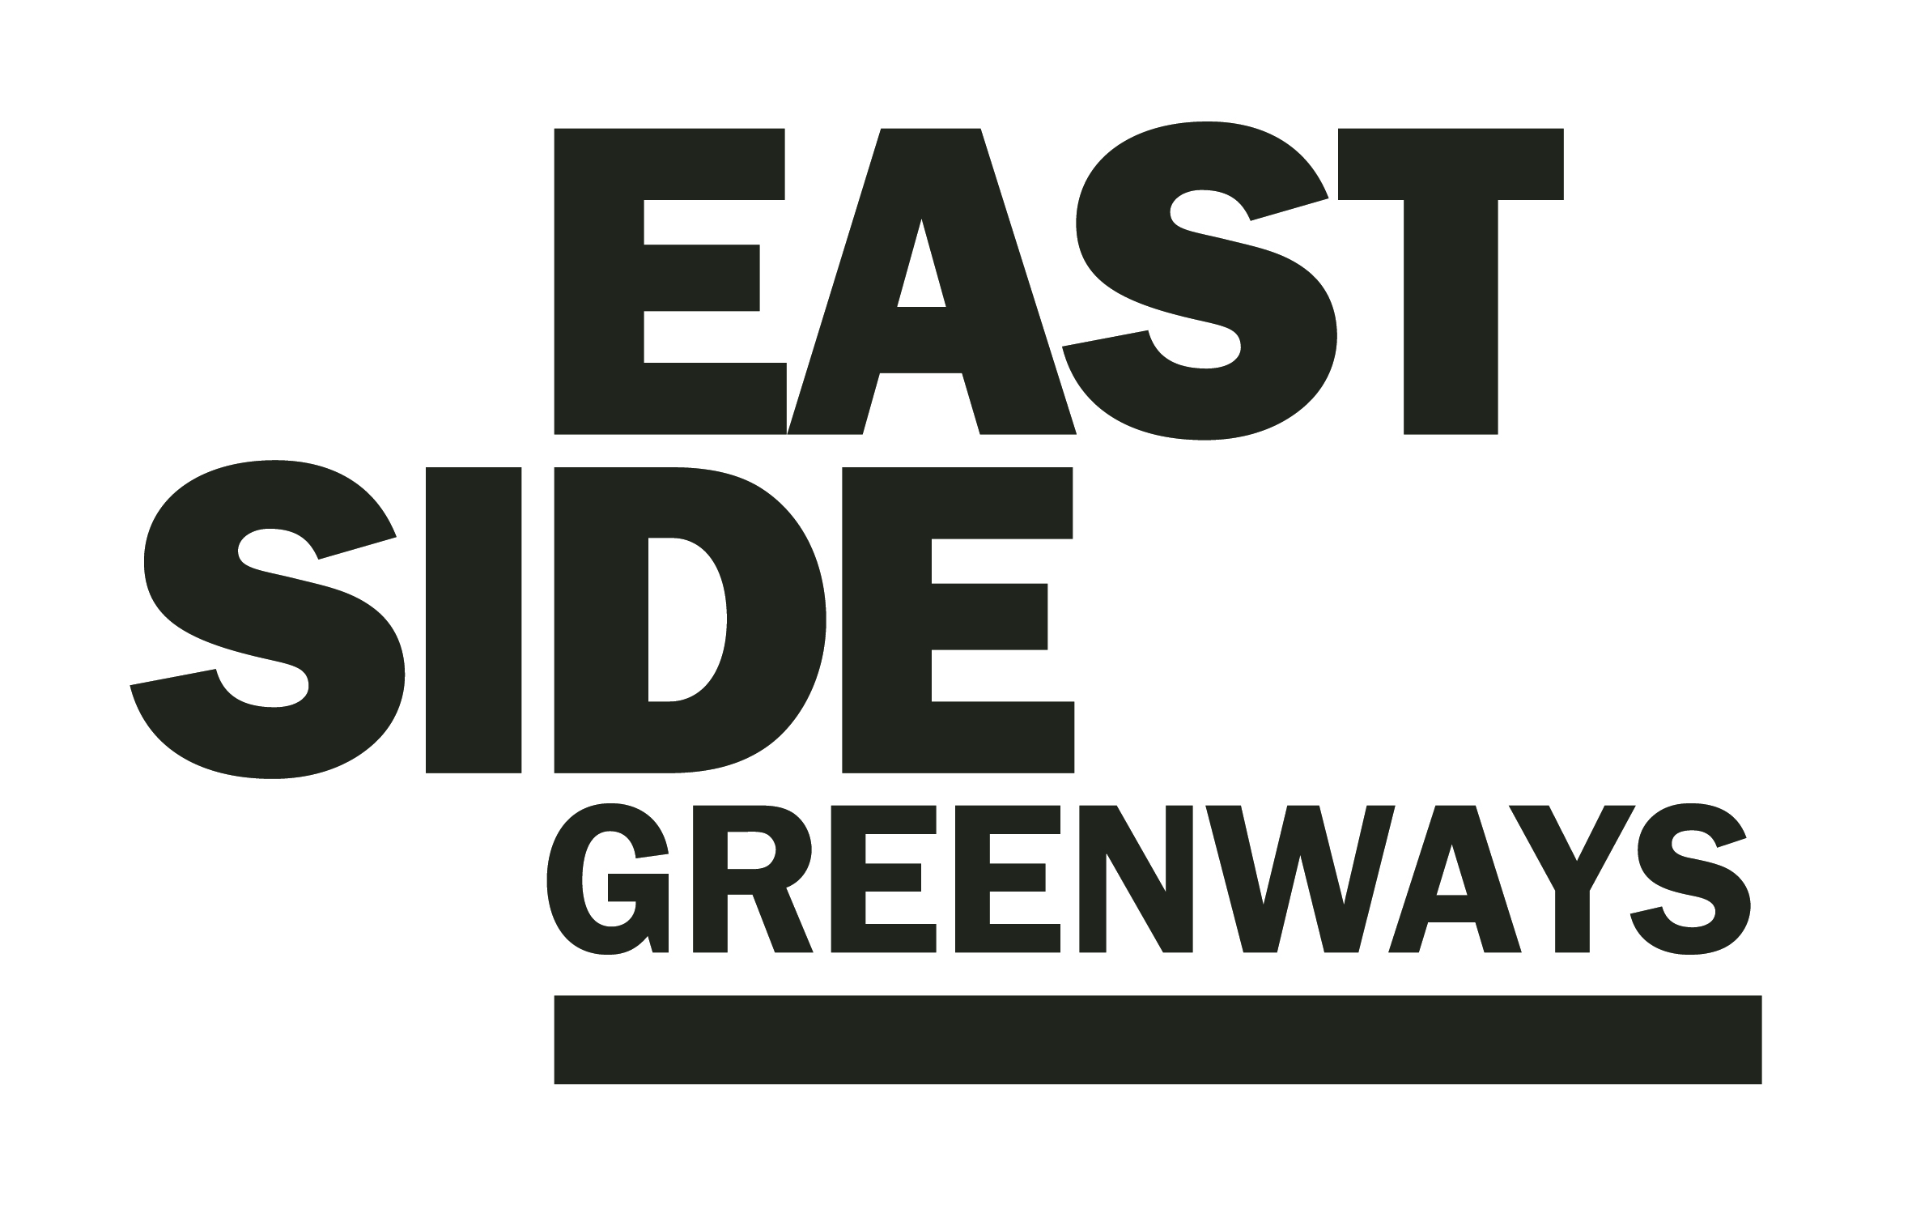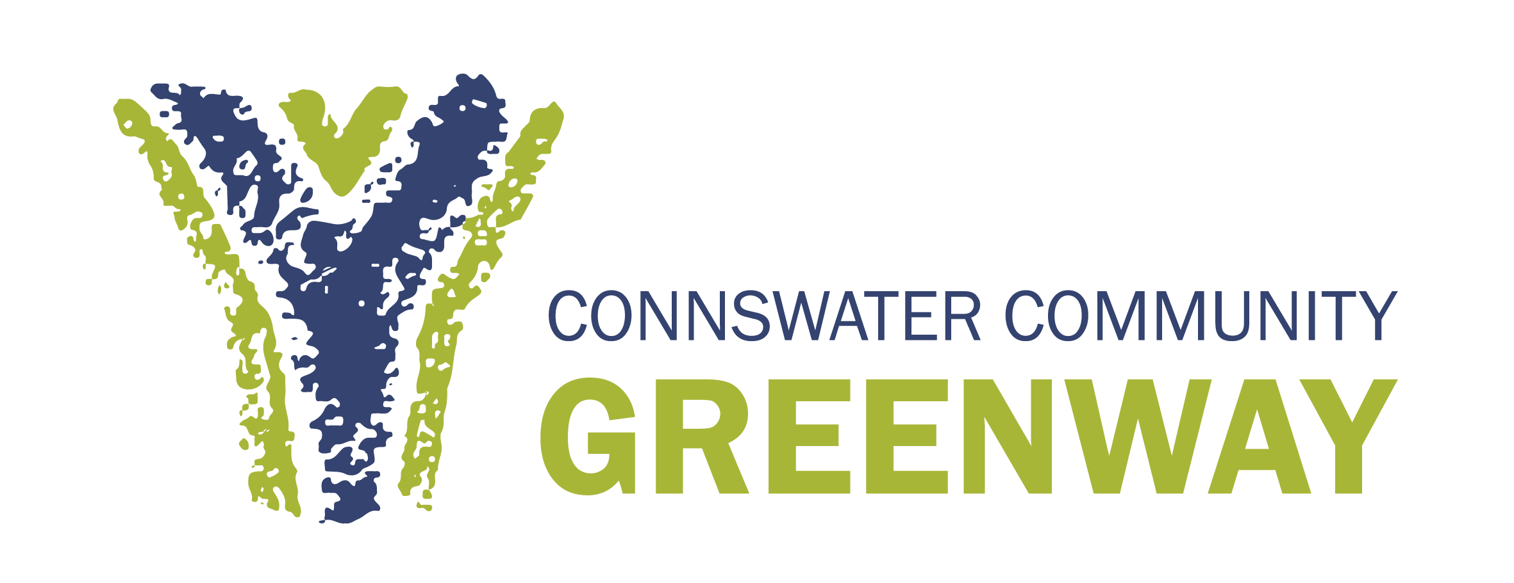

EastSide Greenway’s overall aim is to promote the use and development of green open spaces, parks, rivers and off-road transport routes in east Belfast and to act as a catalyst for the ongoing regeneration or the area.

EastSide Greenway’s strategic objectives are:

- To ensure the sustainability of the Connswater Community Greenway as a living landmark
- To promote the potential for and facilitate the delivery of a wider ‘EastSide Greenways’ network
- To maximise the potential of the Connswater Community and EastSide Greenways to contribute to EastSide’s overarching strategy to deliver social and economic benefit, and enhanced health and well being
- To use the Connswater Community and EastSide Greenways as a catalyst for economic regeneration in east Belfast
- Create new opportunities and promote well - being through the active engagement of local communities and the wider public
- To enhance and conserve the environment along the Connswater Community and EastSide Greenways.

To find out more please visit: www.eastsidegreenways.com

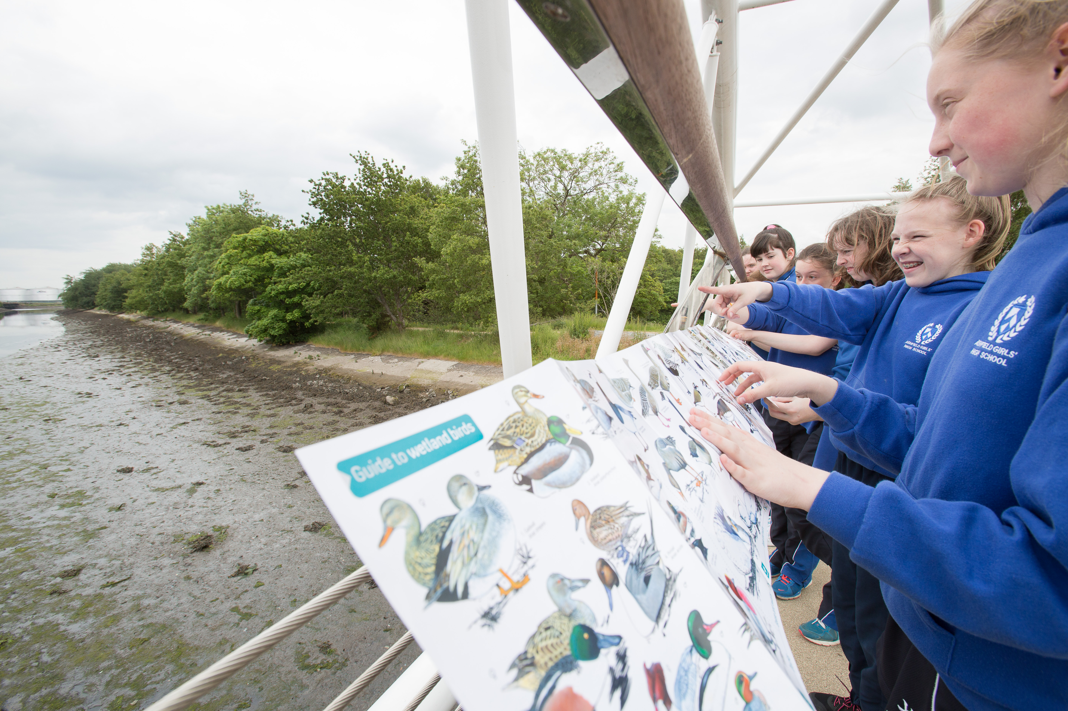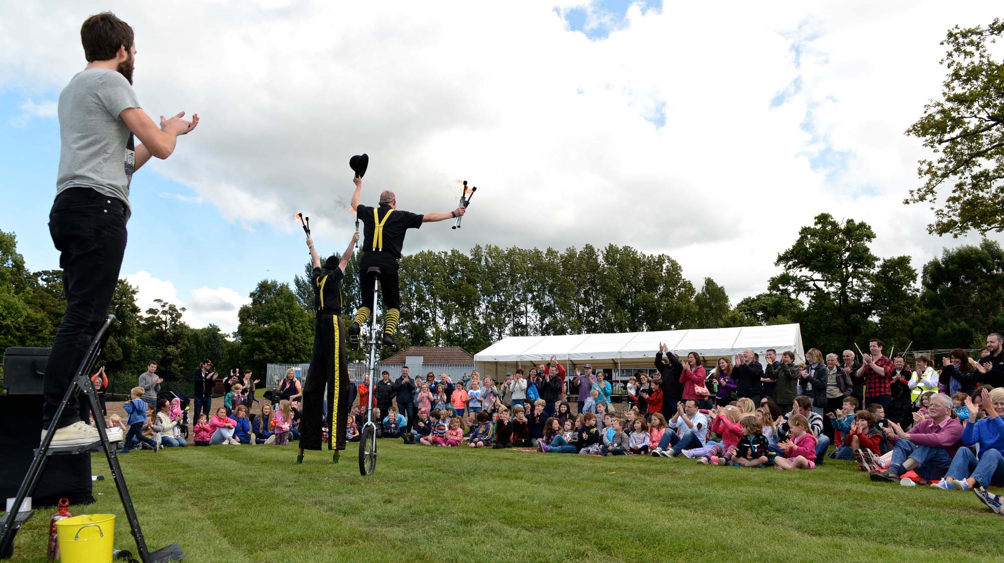

Ref: ESP/ESGYPC22/__

APPLICATION FOR THE POST OF
Youth Project Coordinator

Please complete all relevant sections of this form.

NAME OF APPLICANT:

EMAIL ADDRESS:

This form must be received by email no later than
12.00pm noon on Monday 21st November 2022 to:

gillian@eastsidepartnership.com

GUIDANCE NOTES FOR COMPLETION OF APPLICATION FORMS:

- Please refer to the Job Description and Person Specification, as candidates are only shortlisted for the next stage of the recruitment process on the basis of information contained in the application form which meets the criteria detailed in the Person Specification.
- Please ensure all questions are answered and that you fully complete the application form.
- CVs may be included in addition to the Application Form but please outline how you meet the criteria in this form.
- Applications are to be submitted electronically. Applications received after the above time and date will not be considered. The Equal Opportunities Monitoring Form should also be completed and returned with the Application Form electronically.
- Applications will not be accepted by post or fax.
- The Partnership accepts no responsibility for checking or notifying candidates if forms are unreadable or incomplete for technical reasons.
- Please ensure that you retain the original format of the application form at all times. Boxes may be expanded but please be aware of the word limit indicated.
- We will acknowledge receipt of your application form by email.
- Following shortlisting, if you are successful the next stage of recruitment will be an interview which will take place on Tuesday 29th November

EastSide Partnership is an equal opportunities employer and welcomes applications from all suitably qualified persons. All appointments will be made on merit.

- Personal Details:

Name:

Address:

Contact telephone number:
Email address:

- Employment Details:

Current Employment (if applicable):
Name and Address of Employer:

Post Held:
Duties of Post:

Date Started:
Salary:
Notice period:

Previous Employment:
Name and Address of Employer:

Post Held:
Duties of Post:

Date Started:
Date Left:
Reason for Leaving:

Name and Address of Employer:

Post Held:
Duties of Post:

Date Started:
Date Left:
Reason for Leaving:

Name and Address of Employer:

Post Held:
Duties of Post:

Date Started:
Date Left:
Reason for Leaving:

- Essential Criteria

Please explain how you meet the essential experience and other criteria as detailed in the Youth Project Coordinator Person Specification

Applicants must demonstrate on the application form, by providing personal and specific examples and relevant experience how they meet each of the following criteria:

(a) Provide details of: your third level qualification in a related field and 1 years’ experience in a similar role OR your minimum of 3 years’ experience in a role related to community development, employability or youth development

(Maximum 500 words- expand box as necessary)

(b) Outline your experience of managing projects from development, through planning and delivery

(Maximum 500 words- expand box as necessary)

(c) Outline your experience of working with young people including experience of 1-2-1 work, group work and encouraging personal/ professional development

(Maximum 500 words- expand box as necessary)

(d) Demonstrate your experience of writing and delivering training, employability, skills development and/or OCN accredited training session(s)

(Maximum 500 words- expand box as necessary)

(e) Outline below evidence/ examples of your organisation skills, ability to manage and prioritise workload and meet deadlines and any experience you have of managing budgets

(Maximum 500 words- expand box as necessary)

(f) The Personal Youth Development Programme will use the Connswater Community Greenway as a resource. Training will be focused on outdoor activities such as; horticulture, physical activity, cleansing, tourism. How do you see training and employability for young people fitting in with outdoor spaces and activity?
(Maximum 500 words- expand box as necessary)

- Criminal Convictions

Are you currently subject to any ongoing police investigations or have you ever been convicted of a criminal offence (other than a spent conviction under the terms of the Rehabilitation of Offenders (Northern Ireland) Order 1978)?

Yes No

If yes, give details:

- References

Please give the names, addresses and occupations of two persons not related to you, to whom references may be sent. One of your referees should be your current or previous employer and should be able to comment on your ability to carry out the particular tasks of the role. Please note: references will not be contacted unless you have been offered the role.

1. Current or Previous Employer:

Name:

Address:

Contact Phone Number:

Email address:

2. Other Employer or nominated character referee:

Name:

Address:

Contact Phone Number:

Email address:

I certify that the above information is correct and understand that any false or misleading information, if proved, may result in no further action being taken on this application.

Signed: Date:

Please complete the attached equal opportunities monitoring form on the next page which will be detached from your application before your application is shared with the shortlisting panel.

Equal Opportunities Monitoring Form ESP/ESGYPC22__

Private & Confidential

We are an Equal Opportunity Employer. We do not discriminate on grounds of religious belief or political opinion. We practice equality of opportunity in employment and select the best person for the job.

To demonstrate our commitment to equality of opportunity in employment we need to monitor the community background of our applicants and employees, as required by the Fair Employment and Treatment (NI) Order 1998.

Regardless of whether we practice religion, most of us in Northern Ireland are seen as Catholic or Protestant. We are therefore asking you to indicate your community background by ticking the appropriate box below.

I am a member of the Protestant community

I am a member of the Roman Catholic community

I am a member of neither the Protestant nor Roman
Catholic community

Did you attend a primary, preparatory or secondary school in Northern Ireland?
If yes, please list the names and addresses of all schools attended:

Name of school:

Address:

Name of school:

Address:

Please indicate whether you are: Female

Male

If you do not complete this questionnaire, we are encouraged to use the “residuary” method, which means that we can make a determination on the basis of personal information on file/application form.

Note: It is a criminal offence under the legislation for a person to “give false information in connection with the preparation of the monitoring return”.

